Day 74

DIY

DIY Questions:

1.How to create a docker service named firstsvc with three replicas and image as nginx:1.17. Expose service on port 29999?

Ans:

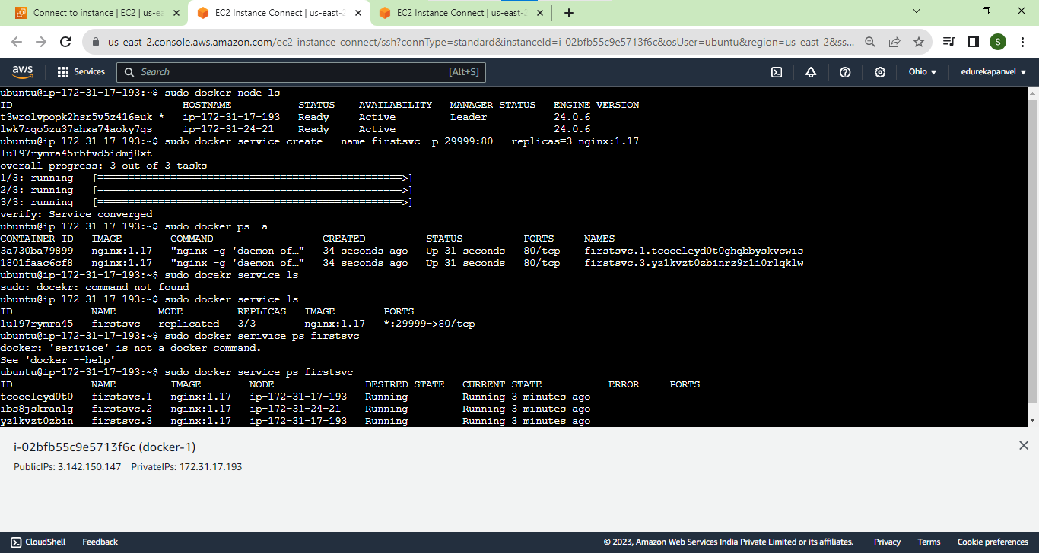

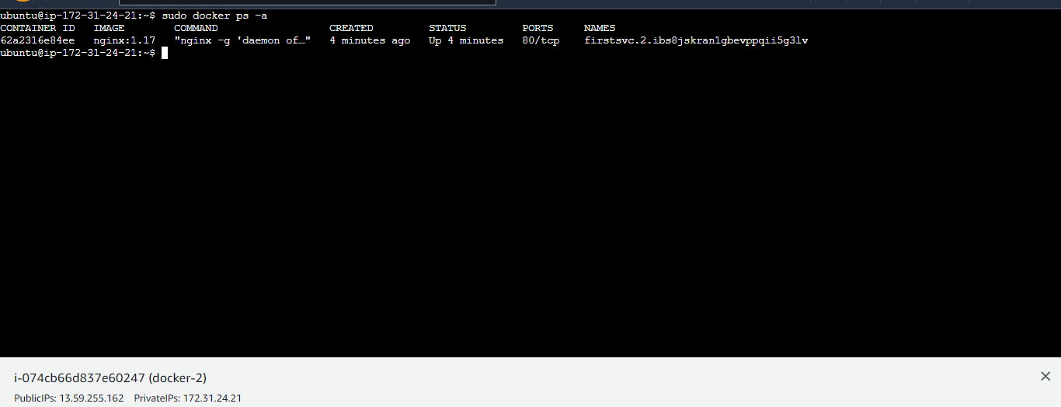

2.How to scale the above-created service from three replicas to four replicas? (Refer to Question 1)

Ans:

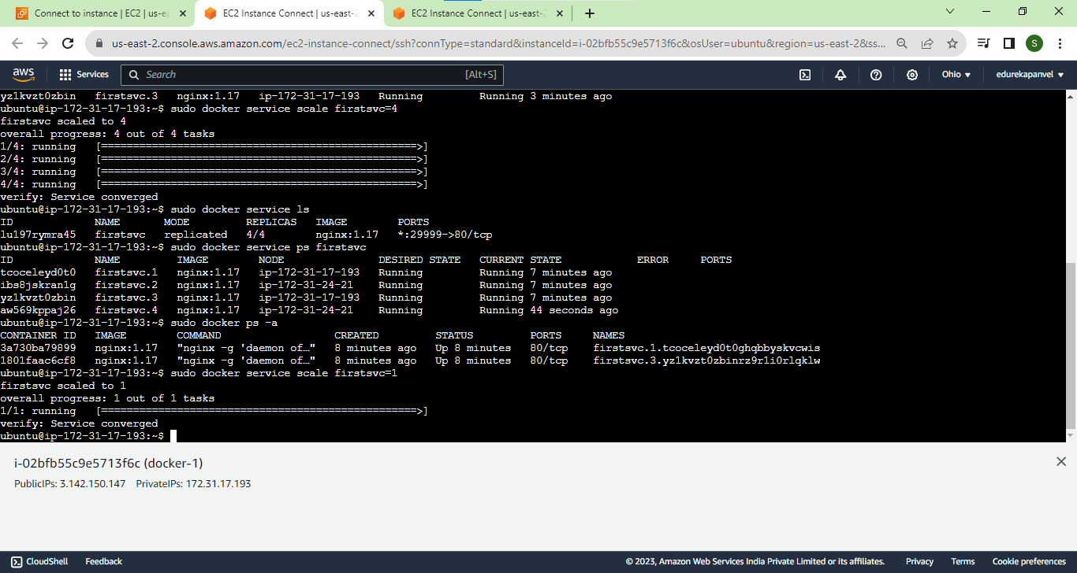

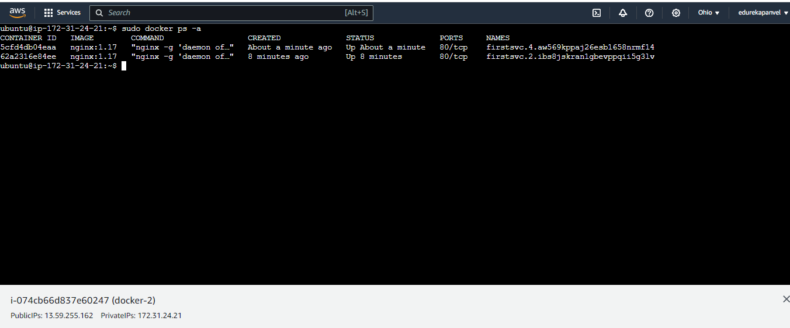

3.How to upgrade the image from version nginx:1.17 to version nginx:1.18 for the above-created image?

Ans:

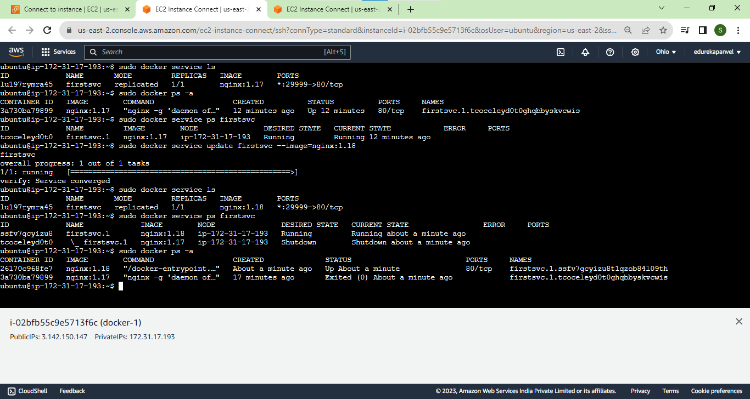

4.How to create a docker service having exactly one container running per node?

Ans:

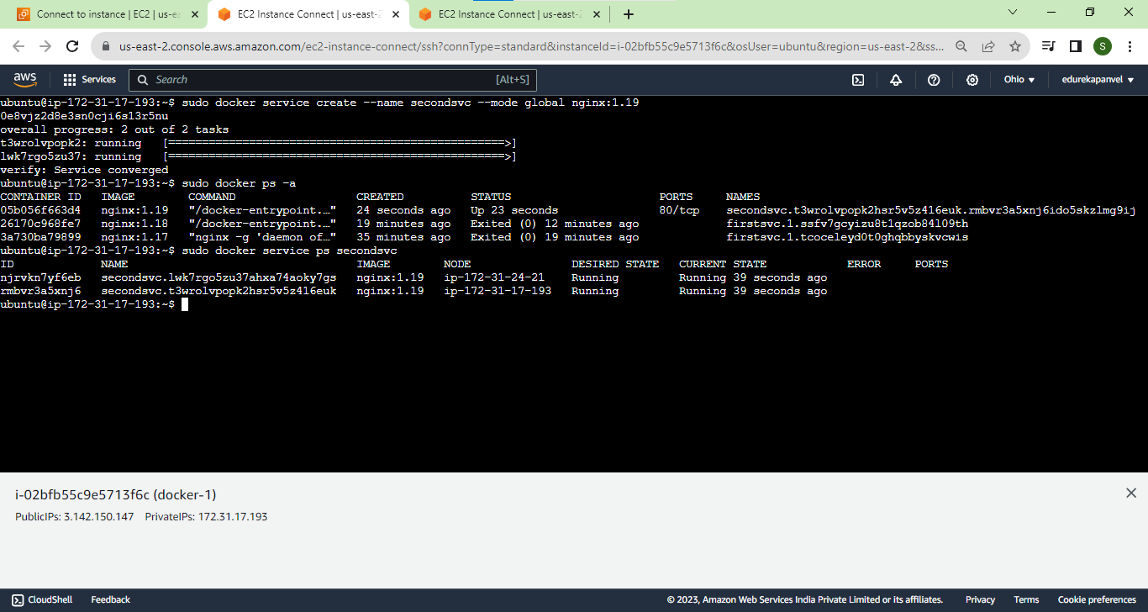

5.How to roll back the service firstsvc from version nginx:1.18 to nginx:1.17?

Ans:

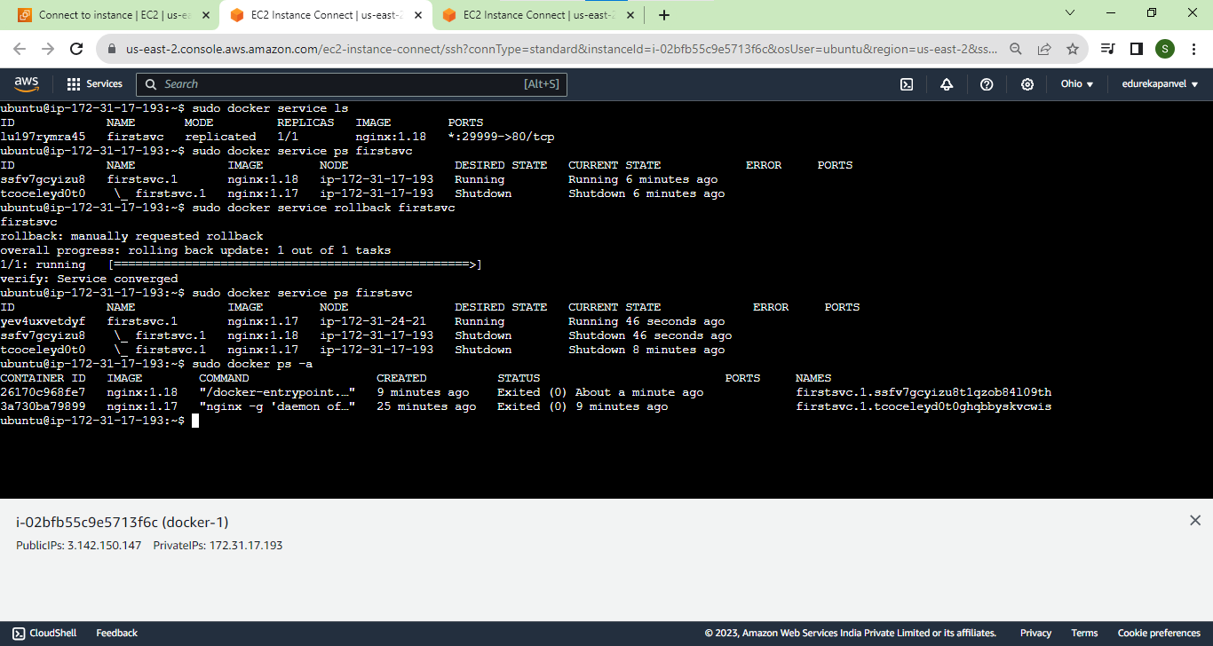

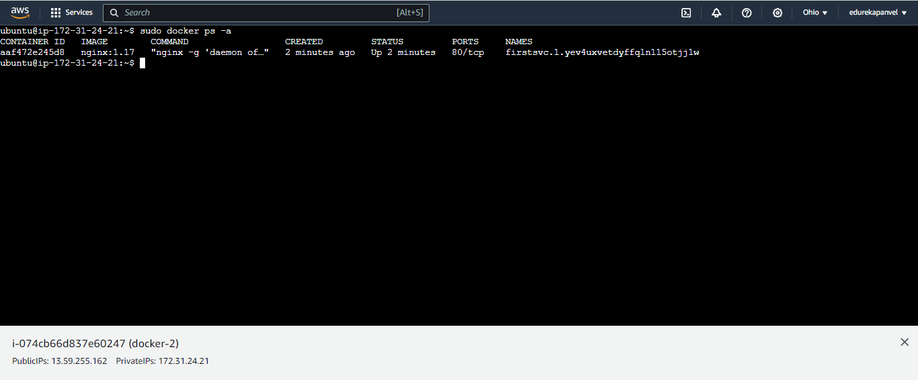

6.How to create a service with one replica and the replica should only be running on the worker node?

Ans:

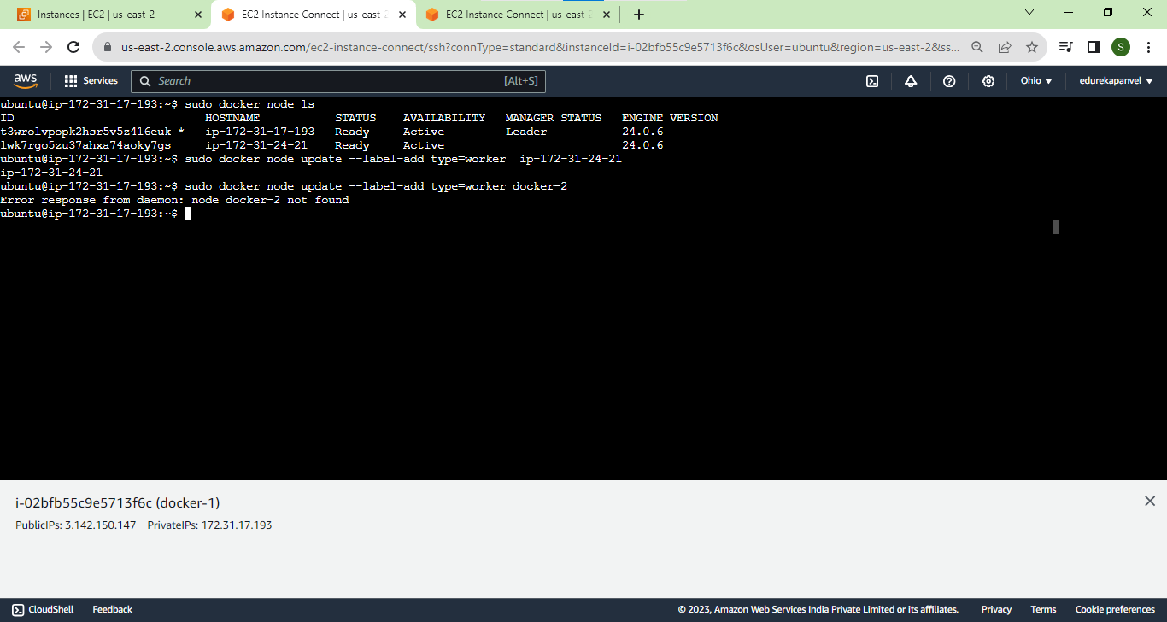

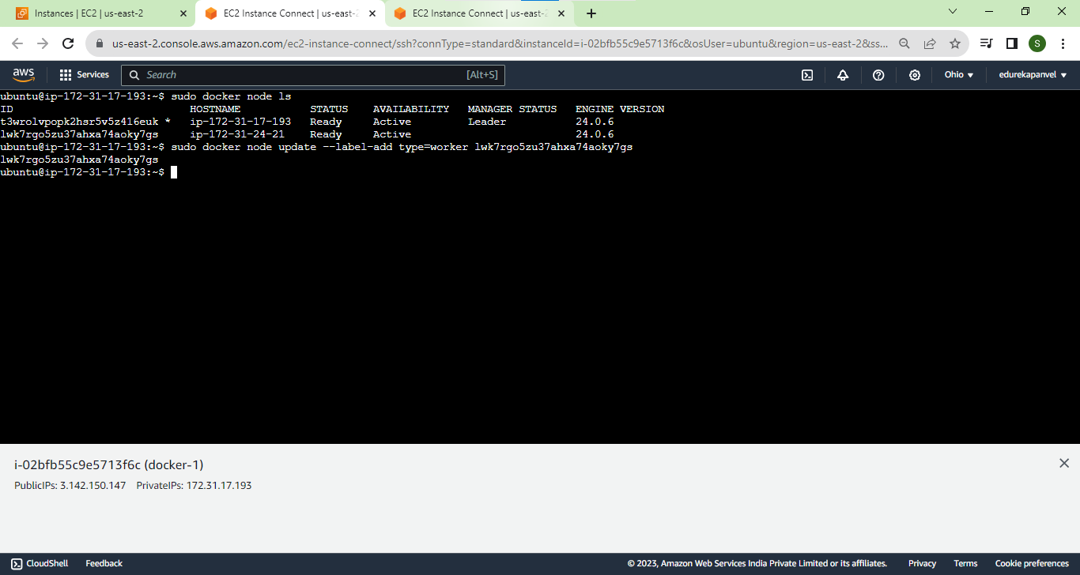

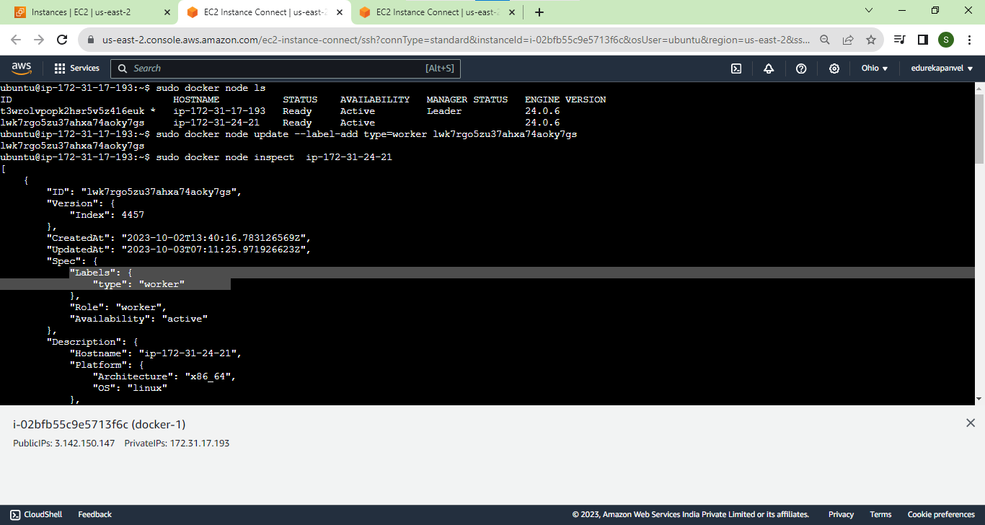

2. add constraint now use this lable while creating a service

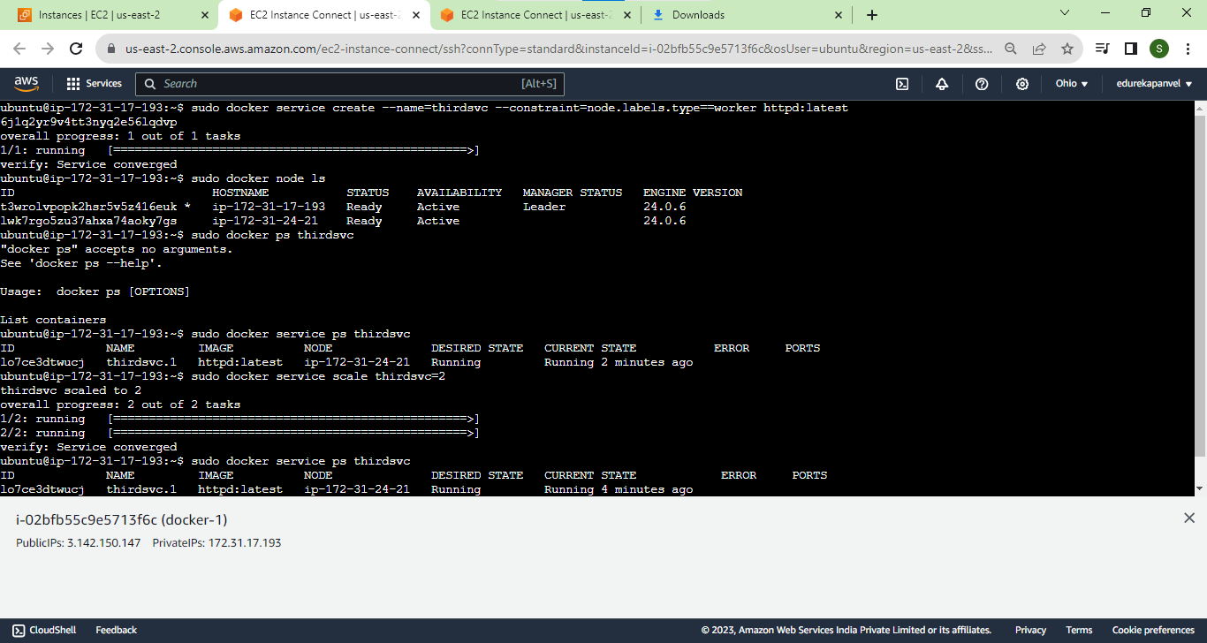

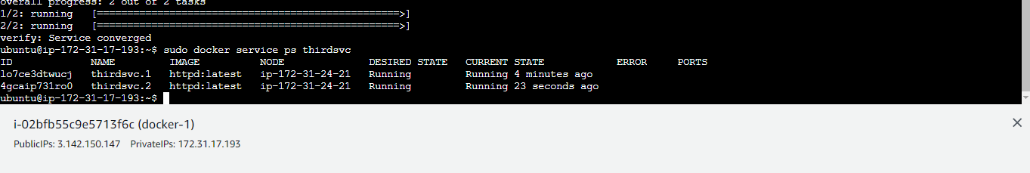

Created on worker node

